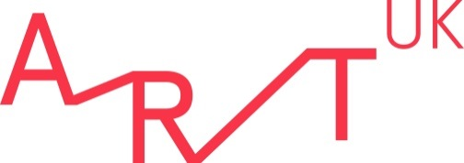

Summer 2021 Work Experience Programme application form

Please complete this form and return to recruitment@artuk.org by 9am on Wednesday 19 May.
We also request that all applicants complete our Equality, Diversity and Inclusion online survey. Please be assured that your responses to this survey will be anonymous and will not form any part of the selection process.
As part of our commitment to Equality, Diversity and Inclusion please note that we redact some details from applications ahead of the shortlisting stage to ensure the removal of unconscious bias. Please note that as part of this process Sections 1, 2 and 6 will be removed from your application form prior to shortlisting.

Section 1: About you
Full name
Address
Email address
Mobile telephone
Date of birth Must be aged over 16 to apply

Section 2: Current status
Education
Name of educational institution
Year of course
Course being studied
Other
Jobseeker |  | Other organisation
Provide further information if needed:

Section 3: Further details
Please indicate your three preferred date options in order of preference i.e. Weeks 4, 7, 1
Where did you see the opportunity advertised?
What type of secondary school did you attend?
(i.e. state, private)
Do you have any access or learning requirements? | Yes/No
If yes, please include details

Section 4: Your interests
Please tell us why you’d like to undertake work experience at Art UK?
How do you plan to continue your interest in art history i.e. in your spare time, at FE/HE, or in your future career?
Do you have a favourite artistic style or movement?
Do you use social media? If so, which platforms do you use?
What elements of the work that Art UK does are you particularly interested in?
What do you hope to get out of your work experience with us?

Section 5: Information in support of your application (200 words max)
Please take this opportunity to tell us more about your interests and skills that you believe are relevant to the placement (i.e. interpersonal, computer, technical, administrative).

Section 6: Parent/Guardian Permission
If you are aged under 18, please ask a parent or guardian to complete this section of the form.
Name
Relationship to work experience applicant
I consent to my child completing an unpaid work experience placement at Art UK | Yes/No
I consent to Art UK processing my child’s personal data in order to process their work experience application. I have read the data protection statement at the bottom of this form and understand. | Yes/No

Data Protection Statement:
The information you give when completing your work experience application form will be used in accordance with the EU General Data Protection Regulation. It will be used to enable the organisation to create electronic and paper records of your application, to enable the application to be processed and to enable the organisation to compile statistics. No statistical information used will be published that would identify you as an individual. The information relating to your application will be kept securely. It will be kept for three months if you are unsuccessful in your work experience application and for the duration of your work experience and three additional months if you are successful. Please read our privacy policy for more details on how we use personal data and information.

